- List all distinct job in Employee.
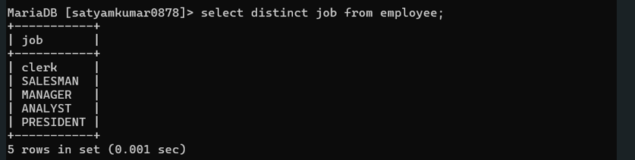
- List all information about employee in Department Number 30.

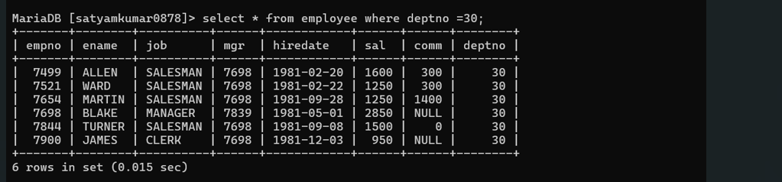
- Find all department number with department names greater than 20.
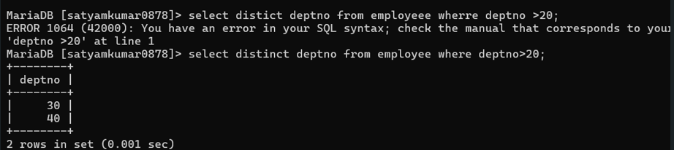
- Find all information about all the managers as well as the clerks in department 30.
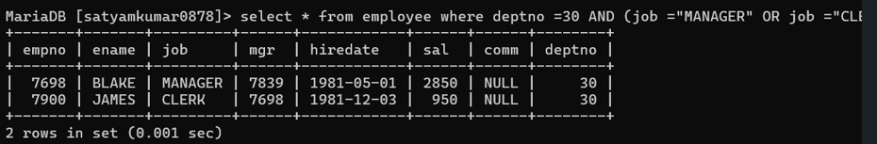
- List the Employee name, Employee numbers and department of all clerks.
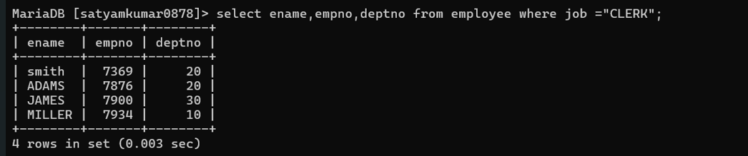
- Find all managers not in department 30.
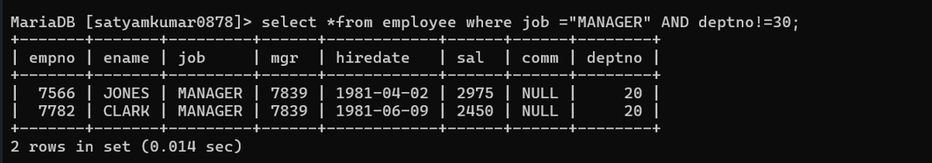
- List information about all Employees in department 10 who are not manager or clerks.

- Find Employees and jobs earning between 1200 and 1400.
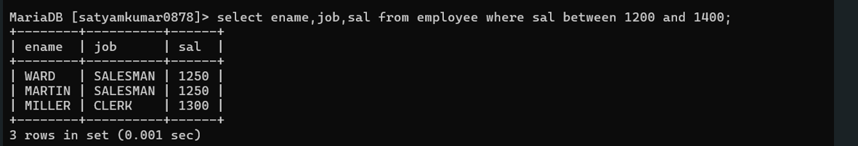

- List Name and Department Number of employee who are clerks, analyst or salesman.
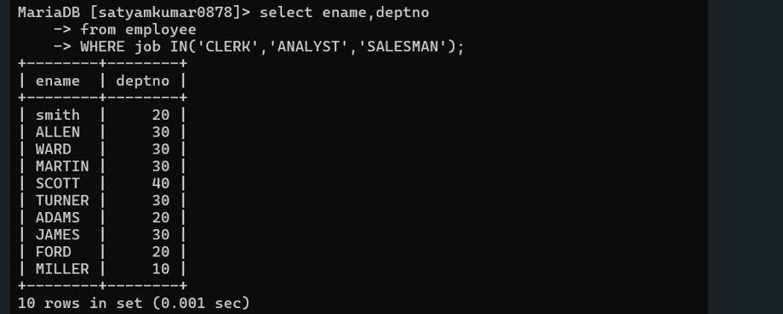
- List Name and Department Number of employee whose names began with M.
